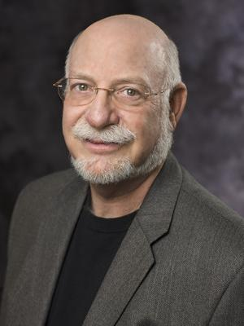
Ronald Romm, a performer who has appeared worldwide on the stages of almost all major concert venues, music festivals, and international music conferences, is widely acknowledged as one of the pre-eminent trumpeters and clinicians of today. Professor Romm was a child prodigy who began his career as a soloist at the age of 10.
By age 12 he was a member of his family's band, the Romm-Antics, and at 18 he was already a veteran freelance trumpeter in Los Angeles, performing regularly with the Los Angeles Brass Society, Los Angeles Philharmonic Orchestra, and Los Angeles Brass Quintet. Professor Romm attended the University of Southern California as a scholarship student of James Stamp. He later transferred to the Juilliard School, where he completed his bachelor's and master's degrees and studied with William Vacchiano, legendary teacher and former principal trumpet of the New York Philharmonic Orchestra. In New York City, Professor Romm performed with everything from the New York Brass Society to the New York City Opera and Ballet Orchestras to the Radio City Music Hall Symphony Orchestra to Broadway shows.
In 1971, Professor Romm joined the newly formed Canadian Brass, which later established itself as the premiere brass ensemble in the world. In June of 2000, he retired from the group after participating more than 4,500 concerts, 60 recordings, numerous television concert specials, videos, and hundreds of master classes. Professor Romm has performed live and recorded CDs with leading artists including Wynton Marsalis, Arturo Sandoval, Jon Faddis, Doc Severinsen, and brass performers from the Boston Symphony Orchestra, New York Philharmonic, Philadelphia Orchestra, Berlin Philharmonic, and Bayreuth Festival Orchestra.
As an educator, Professor Romm has contributed to the growth of brass performance through hundreds of student clinics and master classes worldwide.

