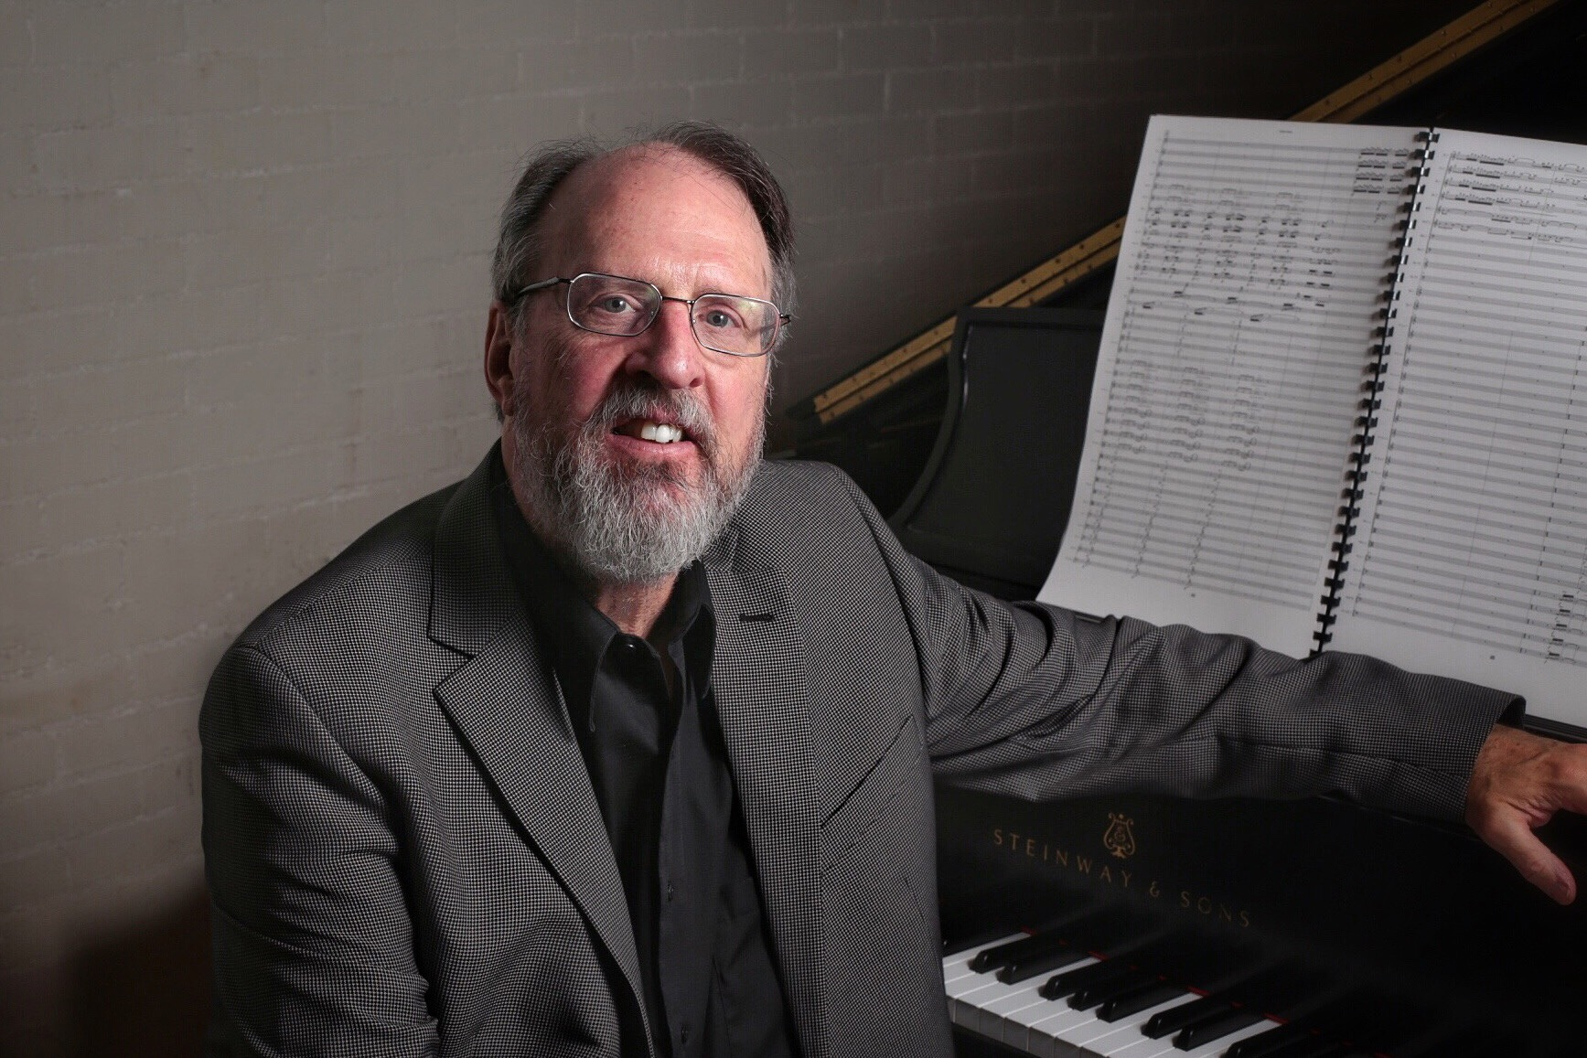

Douglas Ovens, composer

Composer and percussionist Douglas Ovens has performed at the Akiyoshidai International Arts Village in Yamaguchi, Japan, at the Atlantic Center for the Arts, on the Philadelphia Fringe Festival and many other festivals around the United States. He has received commissions from the North/South Chamber Orchestra (New York City), the Allentown Symphony, Lehigh Valley Chamber Orchestra, Asheville Symphony and many modern dance and theater companies. International performances of his music have taken place in Finland, Argentina, Italy, Germany, Poland, Scotland, Japan, and Canada.

Of his solo percussion CD, The American Record Guide said, “His formidable mallet technique impresses me, as does his rich sense of phrasing and line.” Percussive Notes wrote, “Ovens is a creative composer and an excellent performer. His ideas flow easily from one instrument to the other and rhythmic and melodic material are always interesting.” The New York Times said of his piano piece, Moving Image, that it was “a work of special appeal…that has an almost conversational shape and pacing and some wonderful textural detail.”

Dr. Ovens is Professor of Music at Muhlenberg College in Allentown, PA where he served as chair of the department for 18 years.

